Improvement and Innovation Board – End of Year Report

Sector-led Improvement

- During the year we have refreshed our approach to sector led improvement in the light of the results and feedback from the sector to our wide ranging consultation on sector led improvement (taking stock: where next on sector led improvement?) and our on-going evaluation of the key elements of the programme.

- In summary our refreshed approach provides different tiers of support depending on the intensity of the challenges faced locally.

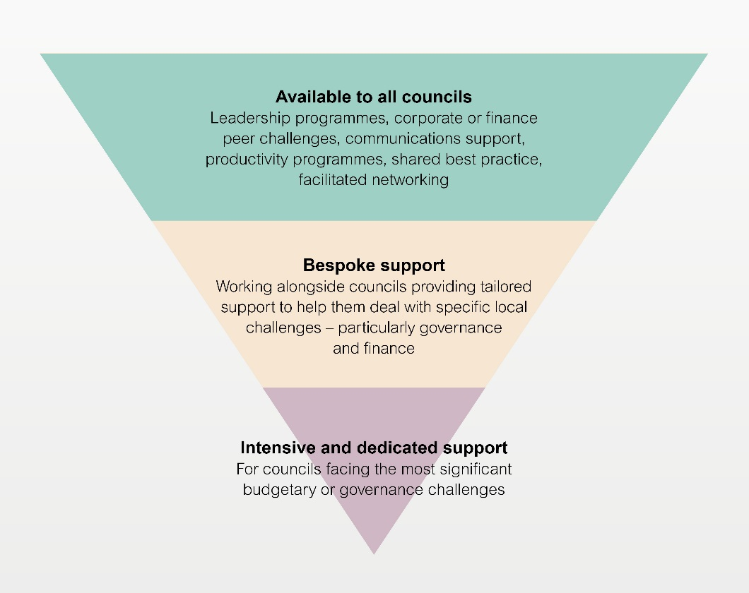

- We are working on the basis that every council and fire and rescue service will have a corporate peer challenge or finance peer review (at no cost) at least every 4-5 years. We also expect participating councils to publish the peer challenge report, to produce an action plan and to have a follow-up visit within two years.

- We keep our offer of support under review and have commissioned a second full-scale evaluation in order to gauge the impact of our support and the extent to which it continues to enjoy the confidence and support of the sector and government. The evaluation will focus on the core elements of the offer (leadership, peer challenge, productivity, LG Inform, etc.) and on their impact.

- The results from the LGA Perceptions Survey continue to demonstrate the sector’s support for the sector-led improvement approach and the value attached to the LGA’s support offer. Over seven in ten respondents (71 per cent) reported that they ‘strongly agree’ or ‘agree’ that the approach to sector-led improvement is the right approach in the current context. This represented a significant increase compared to 2014, when 63 per cent gave a positive response. Four fifths of respondents (84 per cent) believe that the support and resources offered by the LGA for sector-led improvement have had a positive impact on their authority, increasing to 89 per cent of chief executives and 96 per cent of leaders.

Improvement

- Our bespoke sector-led improvement peer support and challenges remain popular. By Quarter 4 of 2015/16, over 100 peer challenges have been delivered covering a range of different areas including corporate, finance, fire, children's and adults.

- By March 2016, councils had contributed nearly 4,000 days of senior councillor and officer time to Corporate Peer Challenge teams representing a considerable investment by the sector in its own improvement, equivalent to millions of pounds of consultancy. We have also held a further 15 peer development or briefing events during the year as we seek to widen our pool of member and officer peers.

- Working through the LGA’s Lead Member Peers and Principal Advisers, we have provided targeted support to individual councils and groups of councils, for example: change of control support to 43 councils, bespoke peer mentoring support to 46 councils, top team development work with 23 councils, follow-up support to 22 councils who received peer challenge and direct improvement support to 131 councils, eg around financial sustainability or where councils are facing specific improvement challenges.

- Public Sector Audit Appointments (PSAA). As regards audit arrangements in local government, the Secretary of State for Communities and Local Government has extended the transitional arrangement for principal local government bodies to 1 April 2018. We estimate that this equates to a saving of £24m for local government. The LGA is supporting an application by Public Sector Audit Appointments Limited (PSAA), a company owned by the Improvement and Development Agency (IDeA), to become the sector-led ‘appointing person’ which would enable councils to opt-in to a form of national procurement of external audit once the transitional arrangements come to an end. Over 200 local government bodies have already expressed an interest in opting-in to a sector-led body guaranteeing that this is an economically viable offer.

Productivity

- A key achievement this year was the launch of the LGA’s Innovative Councils database which has collected together information on innovation from councils across the country and has provide a popular source of information for councils.

- The board worked with a number of sector representative bodies to produce, in December 2015, a set of papers that outline the sector's position and priorities for digital, including: improving online transactional services; transforming local public services; developing the necessary leadership skills to understand and apply digital approaches; coordinating programme leadership and support. Taken together the four papers set out a high-level case for investing in a coordinated and comprehensive programme of support. We have awarded £560,000 funding for digital schemes to projects involving 34 councils through the digital transformation programme. The aim of the programme is to develop digital solutions to support work on national transformation programmes including troubled families and welfare reform, which can be reused by other councils and will enable them to operate more efficiently

- We have launched the LGA demand management microsite. The microsite equips councils with the knowledge and tools they need to manage demand effectively. By bringing together and highlighting examples of demand avoidance and demand prevention from across the country, it demonstrates how councils are changing their relationship with residents to better understand and manage demand.

- We have continued our work on procurement to roll out the National Procurement Strategy, launching two further category strategies relating to social care and IT. We funded 11 projects involving 60 councils to promote efficiency and innovation in waste and recycling, with the potential to save £4m from these projects. The intention is to publish the lessons from this during 2016/17.

- Working with a newly established reference group, the Advanced Commercialisation Group (ACG), we have developed our offer in support of local authority commercial enterprise, seeking to identify the gaps in support available to councils. We have identified a need to give councils better access to markets for commercial advice and training and we are working with the ACG to encourage councils that have been at the cutting edge of commercial good practice to share the lessons learned.

- We commissioned work to assess the efficiency opportunities of integration across health and social care and published interim findings early in 2016 which demonstrated the operational efficiencies and savings, and crucially better outcomes for patients to be found from closer working between councils and the NHS.

- We continued with our successful ongoing offers, providing Productivity Experts to support 24 councils across 15 projects and Growth Advisers also supporting 24 councils across 13 projects to support them in delivering efficiency and income generation projects, running the popular Commissioning Academy for officers and elected members and relaunching our shared services map, which now shows that councils have made more than half a billion in savings from shared service arrangements since 2010.

- More than 100 additional councils are joining the One Public Estate programme, which the LGA is leading with the Cabinet Office. In addition, the Government has announced £31 million of extra funding to expand the programme to more areas. The programme enables local councils to work with other public sector organisations to share buildings and services, reduce running costs and release land for development, and is an excellent example of local government leadership and efficiency.

Supporting Political and Managerial Leadership

- It has been a strong year for bookings onto LGA political leadership development programmes. We delivered 84 events which had over 800 delegates, including 57 council leaders, from 269 different local authorities.

- On 19-20 May, the Leadership Academy graduation took place in Warwick. We have over 140 new Leadership Academy graduates, the highest number since 2010. This has been a record breaking year, with more Leaders than ever attending our programmes.

- The National Graduate Development Programme has proved to be incredibly popular this year with more councils and graduates getting involved than ever before. We are close to placing over 100 graduates with over 60 different councils this year.

- The Be a Councillor campaign has built on a successful pilot in Rotherham to offer bespoke packages to councils who are planning prospective councillor events and activities. A full project has been undertaken with Lancashire County Council which has focussed on modern, innovative ways of attracting potential candidates – for example, the first Be A Councillor film was made, which shows the ‘day in the life’ of a councillor – aiming to bust myths and stereotypes about councillors and what the role involves. Funding for a similar package in Birmingham has now been confirmed, and will focus on the all-out elections in 2018. An event in Isle of Wight is also planned, which will be the first to specifically target getting more women into public office. Increased awareness of the campaign has resulted in contact from a number of councils looking to use Be a Councillor in their own area.

- We held a number of Leadership Essential programmes in Children’s Services, Fire and Rescue, Sport, Getting Your Message Across and Effective Scrutiny. These events provide a chance for councillors to develop leadership skills in a particular area and share experiences among colleagues dealing with similar challenges. A new Leadership Essential Planning programme was launched called ‘New Government and Planning’. This programme is designed to help delegates to take an active leadership role in responding to the challenges that planning services face from the government’s agenda on planning.

- We launched Political Leadership Masterclasses on Working with the Media; Consultation and engagement; Culture Change and Risk Management. These were all well received and will be repeated for the coming year.

- We published a new e-learning module and councillor workbook on scrutiny. The workbook was written in conjunction with the Centre for Public Scrutiny (CfPS) and both resources form part of the Community Leadership offer under the LGA’s Highlighting Political Leadership support. We have also published new e learning modules on Licensing and Regulation and Police and Crime Panels during 2015/16 financial year. We now have over 7500 people signed up to e-learning.

- As part of the wider Sector Led Improvement priorities of the LGA we have provided direct support to six of the regions during the previous financial year (London, South East, NW, East Anglia, West Midlands and SW) by way of bespoke in house training courses and political leadership events.

Transparency & Data

- We have continued to help councils get to grips with the implications of the Local Government Transparency Code by publishing, updating and maintaining practical guidance to help authorities in implementing it. We also ran a support desk for local authority queries about the Code. There were between 4,000 and 9,000 downloads for each of the various guidance documents last year, resulting in 27,000 in total.

- Also as part of the transparency and open data agenda, we engaged with the Open Data Institute to develop online learning modules about publishing data and using open standards for local authorities. These YouTube webinars were a big hit with local authorities, enabling them to learn and ask questions, using a free resource at a time and place which suited them best. Since their launch in March, 130 people have already completed modules.

- We have worked with Land Registry and local authorities to understand the impact that the transfer of local land charges to Land Registry will have on local authorities, and are making the case for funding the burden of that data transfer and ongoing cost.

- We have promoted the better use of data, in particular the value of standards to create data in consistent formats which allow comparisons, to encourage more efficient and effective use of information within authorities. As part of this we have partnered with NESTA in a ‘Local Datavores’ project to explore how the better use of data and analytics can help to innovate and transform services

- Over the course of the year our data benchmarking service for councils, LG Inform, was continually kept updated and new data was also added. The number of data items in LG Inform increased from just over 2,000 to nearly 3,000. New ready-made reports on a range of themes have been added, such as crime and health, to give authorities quick access to a collection of data about their area. As a result, the proportion of authorities with registered users for LG Inform is now 100 per cent, and it is receiving 4,500 visits from over 3,000 unique visitors every month.

- The LG Inform local benchmarking club, which allows councils to compare data with other councils that is either not collected elsewhere or is collected with a time lag, continues to be successful. Over a hundred authorities are regularly submitting data on a voluntary basis, without needing to pay to join a commercial club.

Oversight of LGA Improvement activity

- Members have agreed that it is important for the Improvement and Innovation Board to retain a strategic or “overarching” perspective on the improvement activity currently undertaken across LGA Boards. We have received regular reports on the improvement activity of LGA Boards and had the opportunity, amongst others, to provide strategic input to the development of the integrated Care and Health Improvement Programme for 2016/17; our children’s services improvement work and our developing offer of support on Devolution.

